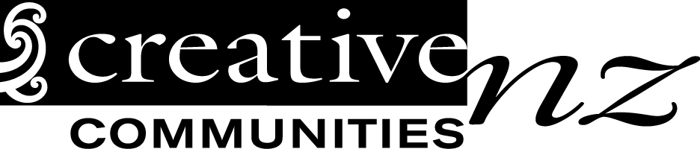
Project Completion Report
This Project Completion Report form must be submitted within two months after your project has been completed.
Please note that if you don’t complete and return a satisfactory report you or your group will not be eligible for future Creative Communities Scheme funding.
Name of applicant:
Project name:
Start date: |  | Finish date:
Number of people who actively participated in your project?
Number of people who came to see a performance or showing of your project?
- Give a brief description of the highlights of your project:
What worked well? What didn’t work? What might you do differently next time? Are there any future plans for this project? If you require more space please attach additional pages.

- How did your project deliver to the criteria that you selected: Participation and access, diversity or young people? If you require more information about these criteria please refer to the CCS Application Guide.
- Financial report: Please give details of how the money was spent.

Project costs – Please exclude GST if you are registered for GST
Write down all of your project costs. Include all items from the budget in your application.
Item  eg. Venue hire | Budgeted cost (from application)  eg $600 | Actual cost  eg $400 | Reason for difference in amounts (if any)  eg Project moved to cheaper venue
Total costs | $ | $
Project Income
Write down all of your project income. Include all items from your application budget. Include your Creative Communities Scheme grant.
Item  eg Ticket sales | Budgeted income (from application)  eg $1600 | Actual  eg $1700 | Reason for difference in amounts (if any)  eg Extra tickets sold
Creative Communities Scheme Grant | $ | $
Total income
Costs less income
You may be required to provide receipts for this project. Please keep your receipts in a safe place for seven years.
- Other material. Please attach copies of any of the following :
- A summary of participant or audience survey results
- Newspaper articles or reviews
- Responses from other people involved in the project
- Responses to the project from other funding bodies or partners/supporters
- Photos of the project and/or artwork
Do we have permission to use these photos to promote the Creative Communities Scheme? |  |  |  | Yes |  | No
Please return your Project Completion Report to:
Julie Parsons:
Julie.parsons@rotorualc.nz
Ph- 07-351-7823 M-027-2424-132
Creative Communities Rotorua Attn Julie Parsons, Private Bag 3029, Rotorua 3046

